### SYSTEM REQUIREMENTS SPECIFICATION

**5.1 PREFACE:**

This document presents the initial version of our Attendance Management System, designed to enhance the efficiency of attendance tracking within the Mathematics department. The system's primary objectives are to facilitate attendance recording, provide faculty members with the ability to view and modify attendance records, enable students to access their attendance status and offer a convenient means for students to report their absence. The development of this system aims to optimize time management for faculty members and empower students to monitor their attendance records.

**5.2 INTRODUCTION**:

5.2.1) PURPOSE:

Our project aims to create an attendance manager for the Department of Mathematics. By creating a user-friendly digital platform, we aim to provide both students and faculty members with an efficient tool to track attendance.

5.2.2) SCOPE:

The attendance manager project aims to develop a user-friendly digital solution that simplifies attendance tracking. The project's scope extends to improve overall attendance management efficiency.

5.2.3) OVERVIEW:

This project focuses on simplifying the approach to attendance tracking. This project makes attendance easy for students and helps faculty manage records smoothly.

**5.3 GLOSSARY:**

**1) Stakeholders-** a person or group of people who are involved within an organization.

**2) Encrypted**-Password of a user puts information into a special form especially in order to stop the user from being able to look at or to understand it.

**3) Default**-Action taken by the attendance manager app itself when it is not given any instructions.

**4) Intentionally aware** of what the user is doing.

**5) An authorized user** is a cleared individual with a requirement to access a system for performing or assisting some feature or task.

**6) Mandatory users** must do or have to obey.

**7) Pop-**a short information is displayed on the screen for our reference.

**8) Consciously** way that shows that you are aware of something or noticing something.

**9) Database-**organized collection of structural information of the data of faculty, students, and admin and the changes made in it.

**10) Inception**-beginning of organization or semester of the academics.

**11) Revamped-**give the new or improved form of structure of the list of the classes and courses.

**12) Absence intimation-**the action of making clear what students think or want without saying it directly.

**13) Cumulative** - successive additions that are done by making changes in attendance.

**14) Criteria-**the standard that users use when they make a decision or form an opinion about somebody/something.

**15) Opted to** make a choice of work to do by the user.

**16) Snack bar** - provides lightweight feedback about an operation or a brief message at the bottom of the screen on mobile.

**17) Freeze** time frame in which a deployment (or similar tasks) cannot take place or rework can’t be done.

**18) Enrollment**-the act of putting someone else onto the official list of members of a group, course, or college.

**19) Demographics** are statistical characteristics of human populations (such as age or income) used especially to identify markets.

**20) Stakeholders-** a person or group of people who are involved within an organization.

**21) Chronological order-** arranging the student's name in alphabetical order in the attendance manager.

**5.4 USER REQUIREMENTS DEFINITION:**

1) Login: As a user, I want to log in to benefit from the use of the application.

2) Logout: As a user, I want to log out to exit the use of the application.

3) Registration: The user should Sign up to benefit from the use of the application.

4) Forgot password: As an authorized user, I want a feature to change the existing password if required.

5) List classes: Our project application can generate a page that gives information about the classes a faculty is teaching to bring the pages related to that class.

6) Take attendance: This feature provides the main requirements of the user to take and display attendance of each course.

7) View forms: The View Forms Page displays the absent intimation forms for faculty sent by the Students.

8) Overall attendance(Faculty): As an authorized faculty, I want to view and edit the cumulative attendance of every student in their respective course.

9) Attendance list(Faculty): As a logged-in faculty after opting for a class, I want to view every student's attendance data for that opted class along with an edit option of the particular dates provided if not asked for attendance of a particular student and, if so attendance of the particular student shall be provided with the modifying option.

10) Reschedule class: As a logged-in faculty, I shall be able to reschedule the class if I need.

11) Settings(Faculty): The Faculty Settings shall provide options for managing attendance-related preferences, including the ability to set a freeze period for attendance, receive notifications, select a theme for the app interface, should be able to change their password.

12) Overall attendance(student): The attendance manager shall generate a view attendance page displaying the attendance percentage for the student secured in each subject.

13) Take form: The attendance Manager shall generate the absence intimation form through which students intimate about their absence with reason before the absence date to the faculty.

14) Settings(student): The Student Settings shall provide options for switching notifications when their attendance falls between 65 to 75 per cent, and select a theme for the app interface.

15) Attendance list(student): As an authorized student, I want to view the attendance list displaying the attendance status of each date and if required, on the given range of dates.

16) Manage faculties: The system should allow the admin to efficiently manage faculty profiles and provide access to a faculty list.

17) Manage courses: As a logged-in admin, I want the system should allow me to efficiently manage courses and provide access to a course list.

18) Manage students: Administrators should be able to register new students by entering their personal information, contact details, and enrolment data.

19) View attendance: First, the admin is provided with information on the different courses, each with a different semester that the department provides and each class shows the current percentage of attendance of the students.

**5.5 SYSTEM ARCHITECTURE:**

A repository architecture consists of a central data structure (often a database) and a collection of independent components that operate on the central data structure. Each component of the attendance management system provides each service only through the data from the database that is built to maintain the information. So it is the responsibility of every user to provide appropriate information to the system. Hence We follow the repository architecture for the system.

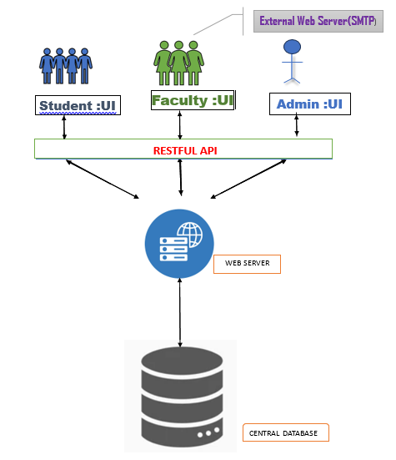

Fig. 5.1 system architecture

**5.6 SYSTEM REQUIREMENTS SPECIFICATION:**

1) FUNCTIONAL REQUIREMENTS

1.1) SHARED

1.1.1) LOGIN

1.1.1.1) It is mandatory to Sign up first before you log in.

1.1.1.2) Login contains the User ID and password.

1.1.1.3) If the user is faculty, then the User ID should contain 6 digits.

1.1.1.4) If the user is a student, then the User ID should contain 10 digits with the first 4 digits of the year of joining, the next 3 digits of the program code and the last 4 digits of your Roll number.

1.1.1.5) Password should contain at least 8 characters but at most 14.

1.1.1.6) Password should contain at least one uppercase letter, Lowercase letter, Number and a Special character.

1.1.1.7) Passwords are encrypted by default, you can see when needed by using the near icon.

1.1.1.8) when you click the Login button, if all the above condition is satisfied, then your login is successful.

1.1.1.9) If not, then it will pop an error message showing the “Invalid User ID or Password”.

1.1.2) LOGOUT

1.1.2.1) Once a user asks for log out, a confirmation box appears to ensure that the user needs to log out of the application intentionally.

1.1.2.2) Once logged out, the application is in general and anyone can log in again to benefit from the use of the application with the authorized user ID and its appropriate password.

1.1.3) REGISTRATION

1.1.3.1) When a user needs to use the application, signing up for the application is mandatory.

1.1.3.2) Sign-up contains User ID, Email, Password.

1.1.3.3) If the user is faculty, then the User ID should contain 6 digits.

1.1.3.4) If the user is a student, then the User ID should contain 10 digits with the first 4 digits of the year of joining, the next 3 digits of the program code and the last 4 digits of your Roll number.

1.1.3.5) The user should provide a valid Email ID.

1.1.3.6) The Email ID is verified by sending the notification, that is, OTP to check whether the User’s valid ID or not.

1.1.3.7) Password should contain at least 8 characters but 14 or more is better.

1.1.3.8) Password should contain at least one Uppercase letter, Lowercase letter, Number and Special character.

1.1.3.9) Passwords are encrypted by default, you can see when needed by using the gear icon.

1.1.3.10) When you click the Sign-up button, if all the above condition is satisfied, then your account is created.

1.1.3.11) If not, then it will pop an error message showing the “Invalid register”.

1.1.4) FORGOT PASSWORD

1.1.4.1) First input the new password.

1.1.4.2) Password should contain at least 8 characters but at most 14.

1.1.4.3) Password should contain at least one uppercase letter, one lowercase letter, a number and a special character but not whitespaces.

1.1.4.4) Passwords are encrypted by default, you can see when needed by using the near icon.

1.1.4.5) You have to re-enter the password to ensure that the user sets the password consciously.

1.1.4.6) To verify the user modifies his own password, the system will send an

OTP to verify that the user has authentication and then modify the password.

1.1.4.7) The new password is also updated in the Database.

1.2) FACULTY: -

1.2.1) LIST CLASSES

1.2.1.1) At the inception of every semester, once the faculty has designated the classes he or she should be instructed in, the list of the classes will be revamped on the screen.

1.2.1.2) The data the system shall exhibit may include the course and the branch, the course name with the appropriate course code.

1.2.2) TAKE ATTENDANCE

1.2.2.1) The faculty should mention the date and hour of the class.

1.2.2.2) This page provides a summary of student’s names with their respective register number.

1.2.2.3) The default toggle button will be present; faculty can update if absent.

1.2.2.4) After taking the attendance, the faculty should submit, it so that it will be stored permanently.

1.2.2.5) Once the absence intimation form is provided, that particular student is marked absent for the mentioned dates automatically.

1.2.2.6) On the last working day of every semester, the attendance will be frozen automatically.  Then, no updating can be done by faculty.

1.2.2.7) On the last working day, the summary of the attendance will be generated and the system generate a report

1.2.3) VIEW FORMS

1.2.3.1) The View Forms Page shows the roll number, name and date of absent intimation forms sent by the students.

1.2.3.2) The fonts of the read forms are light-coloured, while the unread forms are dark-coloured.

1.2.3.3) While the user clicks on the roll number, they are taken to another page where the reason for the student's absence is shown.

1.2.4) OVERALL ATTENDANCE

1.2.4.1) This page shows the student’s name with their respective roll number.

1.2.4.2) The faculty can view the total number of hours that the particular student is present in the course.

1.2.4.3) The faculty has the ability to modify if the minimum criteria of the crisis go down.

1.2.4.4) The page will be updated as soon as the faculty modifies and submits attendance.

1.2.5) ATTENDANCE LIST:

1.2.5.1) The system shall provide two calendars to select a range of dates which are mandatory fields to be filled by the faculty.

1.2.5.2) A register number or the name of the student whose attendance data should be displayed may be provided by the faculty to make searching for a particular student's attendance data easy.

1.2.5.3) The system shall provide the attendance data in a table with absence indicated in red colour and an edit option in the last if the faculty needs to modify the attendance data of any student.

1.2.5.4) Once the faculty edited the attendance data of a student(s), the system shall automatically update the modification in the database and reflect the change wherever needs to be.

1.2.5.5) Once the modification is successful, a snack bar indicating that the modification is successful can appear and return to the Attendance List page with the modified attendance data of the same student.

1.2.6) SETTINGS

1.2.6.1) The system shall provide a user-friendly interface for faculty members to set a freeze period for attendance submission.

1.2.6.2) The system shall prevent changes to attendance records, and absence intimation form submissions during the specified freeze period.

1.2.6.3) The system shall integrate a notification mechanism to inform faculty members about submitted absence intimation forms.

1.2.6.4) Notifications about absence intimation forms shall be generated with the date when the student submits the form.

1.2.6.5) The system shall offer a selection of predefined themes for faculty members to choose from.

1.2.6.6) The system shall provide a secure password change process for faculty members.

1.2.6.7) Faculty members shall need to provide appropriate verification to change their passwords.

1.3) STUDENT: -

1.3.1) OVERALL ATTENDANCE

1.3.1.1) The system compiles the attendance data for each student and each course and calculates their respective attendance percentages.

1.3.1.2) The system shall automatically generate the attendance percentage for each student whenever there is an update.

1.3.1.3) Page includes the subject code, subject title and the attendance percentage for that course.

1.3.1.4) By the attendance criteria:

1.3.1.4.1) An attendance percentage of 75% or higher will be represented as green.

1.3.1.4.2) Attendance falling within the range of 65% to 75% will be depicted in orange, indicating the requirement for a medical certificate or the on-duty form must be submitted to permit them to take the end-semester examination.

1.3.1.4.3) Attendance percentage below 65% will trigger a change to the colour red, indicating that the student will not be eligible to write the end-semester examination.

1.3.1.5) Student will get an attendance alert mail if their attendance for any subject falls between 65% and 75%.

1.3.1.6) Students can only view their attendance percentage. They don't have permission to edit.

1.3.2) TAKE FORM

1.3.2.1) Absence intimation form shall be forwarded automatically to the faculties to whom the student wants to intimate.

1.3.2.2) Students should choose the appropriate course code so that the system will send it to the faculty who is the instructor of the particular course.

1.3.2.3) The page includes the reason for absence, date of absence, and number of hours of absence.

1.3.2.4) Students should receive a confirmation or acknowledgement once their absence notification is successfully submitted and confirmed by the faculty.

1.3.2.5) Students should be able to view a history of their previously submitted absence intimations.

1.3.2.6) If the percentage of attendance of a particular course of the student is below 75% the absence intimation form submitted by the student becomes invalid.

1.3.3) SETTINGS

1.3.3.1) The system shall generate notifications for students when their attendance falls between 65% to 75%.

1.3.3.2) The system shall prevent students from submitting absence intimation forms during the attendance freeze period.

1.3.3.3) The system shall provide appropriate notifications to students about the freeze period.

1.3.3.4) The system shall offer predefined themes for students to choose from for the app interface.

1.3.3.5) The system shall implement a secure process for students to change their passwords.

1.3.3.6) The system shall implement a secure process for students to change their passwords.

1.3.4) ATTENDANCE LIST:

1.3.4.1) The system shall provide two calendars to select a range of dates which are mandatory fields to be filled

1.3.4.2) The subject code or the name of the subject may be provided by the student to make searching for the attendance data easy.

1.3.4.3) The system shall provide the attendance data in a table with absence indicated in red colour.

1.3.4.4) Once the faculty edited the attendance data of a student(s), the system shall automatically update the modification in the database and reflect the change wherever needs to be.

1.3.5) RESCHEDULE CLASS

1.3.5.1) The system shall provide a list of classes of the current date, each class associated with a rescheduled option.

1.3.5.2) The system may also provide a reschedule option globally with a calendar option to provide a date as input on which the faculty needs to reschedule the class.

1.3.5.3) When the faculty provides a particular date in the global option, the system shall display the list of classes on that particular date with a rescheduling option.

1.3.5.4) When the faculty opts for rescheduling a particular class, the system may pop up a dialogue box to provide inputs.

1.3.5.5) The inputs of the rescheduling may include the date and hour to which the class is rescheduled.

1.3.5.6) The system shall check with timetable and details of other rescheduled classes and reschedule the class if the faculty is free during the hour or inform the faculty that the hour is blocked for other classes.

1.3.5.7) Once the faculty rescheduled a class, the system shall send a notification to all the students who enrolled on that course through email.

1.3.5.8) The system shall also store the rescheduled class in the database and shall display it along with the regular class on that particular date.

1.3.5.9) The system shall give an option to return to display the list of classes on the current date.

1.4) ADMIN: -

1.4.1) MANAGE FACULTIES

1.4.1.1) The system shall display a list of registered faculty members for admin access.

1.4.1.2) Faculty profiles shall consist of name, contact information, department, and research areas.

1.4.1.3) The system shall provide a user interface that allows the admin to add, edit, and remove faculty profiles.

1.4.2) MANAGE COURSE

1.4.1.1) The system shall display a list of courses with the details associated with it.

1.4.1.2) The course list shall consist of course name, course code, semester which enjoys that course and their total credits.

1.4.1.3) The system shall provide a user interface that allows the admin to add, edit, and remove the courses.

1.4.2) MANAGE STUDENTS

1.4.2.1) Administrators should be able to easily enrol new students into the system by entering their personal information, contact details, and enrollment dates.

1.4.2.2) Administrators should be able to manage course enrolments, including selecting courses, dropping courses, and viewing course schedules.

1.4.2.3) Administrators should be able to record and monitor student attendance for classes, meetings, and events.

1.4.2.4) Administrators should have the ability to view, edit, and update student records, including demographics, academic progress, attendance, and disciplinary history.

1.4.2.5) Administrators should be able to manage courses, including adding, modifying, and deleting courses, and assigning instructors.

1.4.2.6) Administrators should have the ability to send announcements, notifications, and important updates to students, instructors, and staff.

1.4.3) VIEW ATTENDANCE

1.4.3.1) The admin can view the general attendance of students.

1.4.3.2) The page displays a range of student attendance percentages from lower to higher by register number or by the chronological order of the student's name by sort option.

1.4.3.3) The attendance of the students is updated automatically once the teacher submits the attendance of the particular hour.

1.4.3.4) By the attendance criteria:

1.4.3.4.1) An attendance percentage of 75% or higher will be represented as green.

1.4.3.4.2) Attendance falling within the range of 65% to 75% will be depicted in orange, indicating the requirement for a medical certificate or the on-duty form must be submitted to permit them to take the end-semester examination.

1.4.3.4.3) Attendance percentage below 65% will trigger a change to the colour red, indicating that the student will not be eligible to write the end-semester examination.

**5.7 SYSTEM MODELS:**

**5.7.1 USE CASE DIAGRAM:**

Fig. 5.2 use case diagram

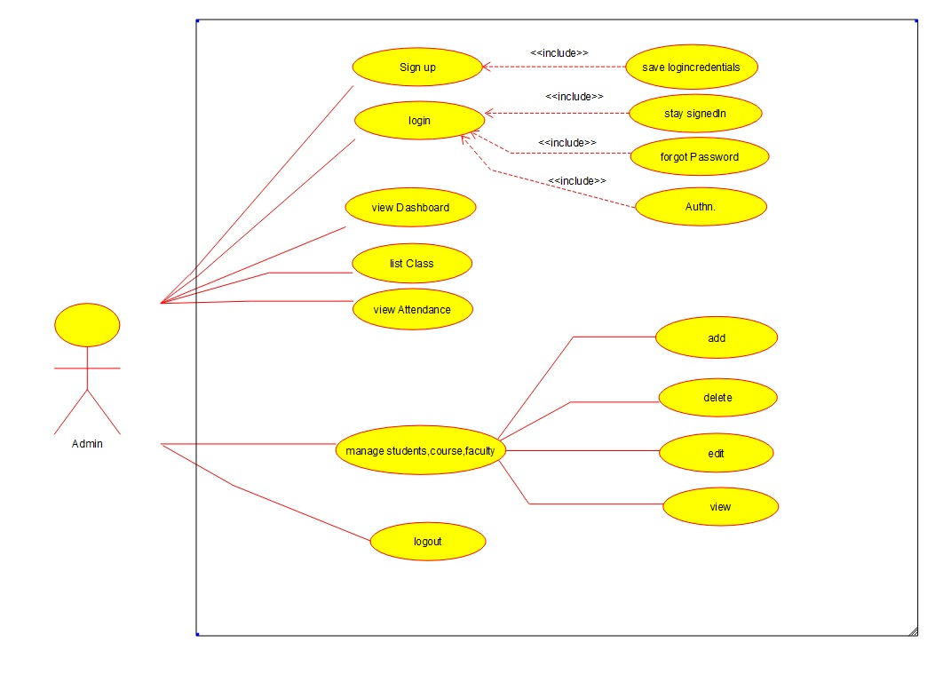

Fig. 5.2.1 use case diagram for admin

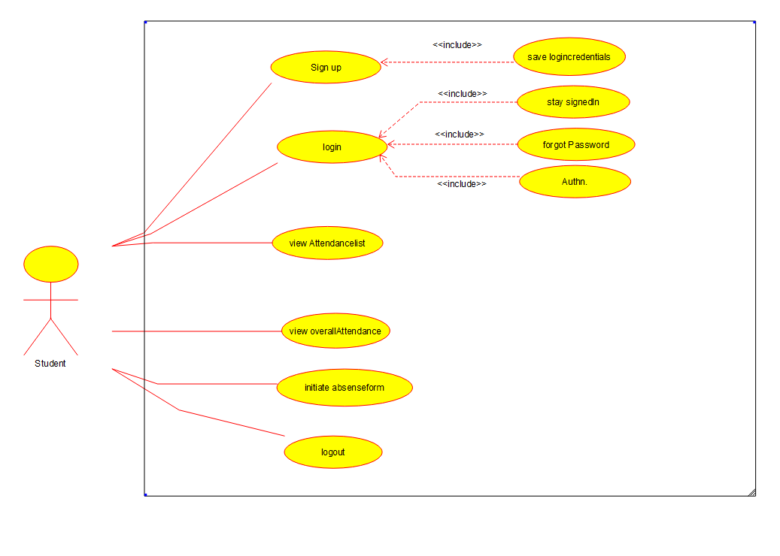

Fig 5.2.2 use case diagram for student

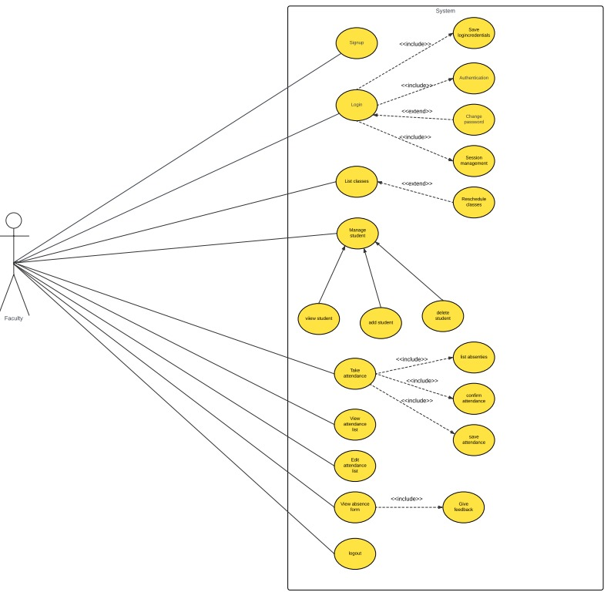

Fig. 5.2.3 use case diagram for faculty

**5.7.2 CLASS DIAGRAM:**

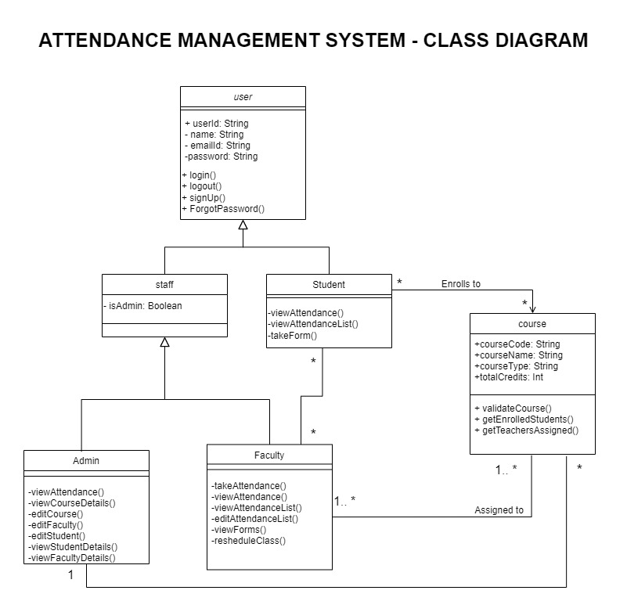

Fig. 5.3 class diagram of the system

**5.7.3 SEQUENCE DIAGRAM:**

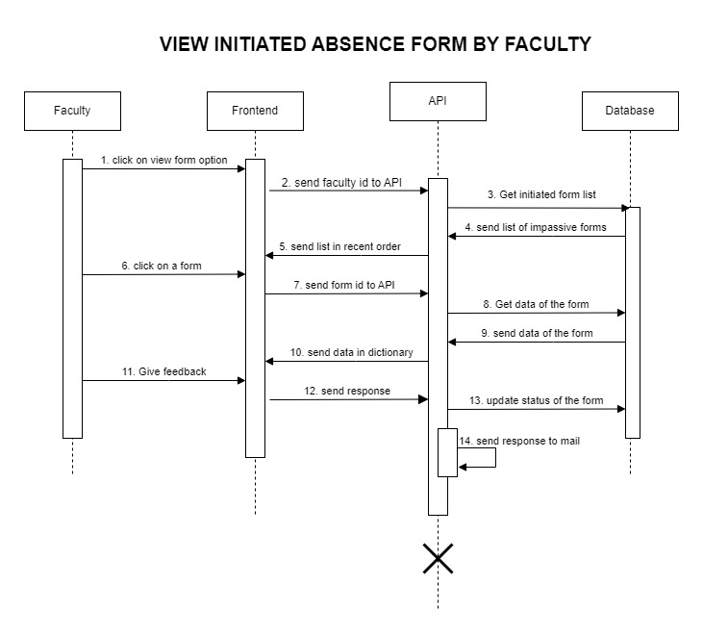

Fig. 5.4 sequence diagram 1 (viewing of initiated form by faculty)

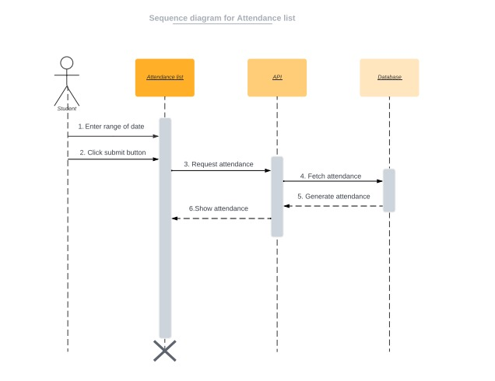

Fig 5.5 sequence diagram2 (viewing attendance on daily bases by student)

**5.7.4 STATE DIAGRAM**

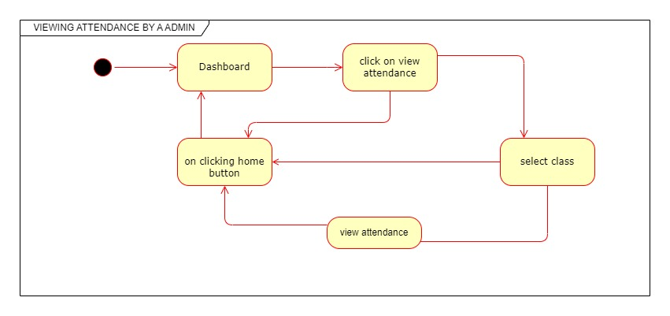

Fig. 5.6 state diagram 1 (viewing attendance of a class feature for admin)

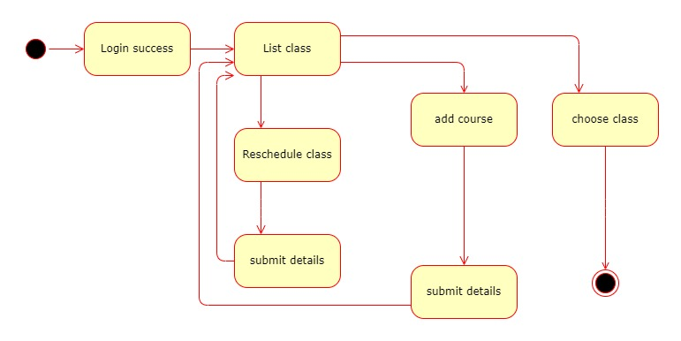

Fig. 5.7 state diagram 2 (viewing listed class for faculty)

**5.7.5 ACTIVITY DIAGRAM**

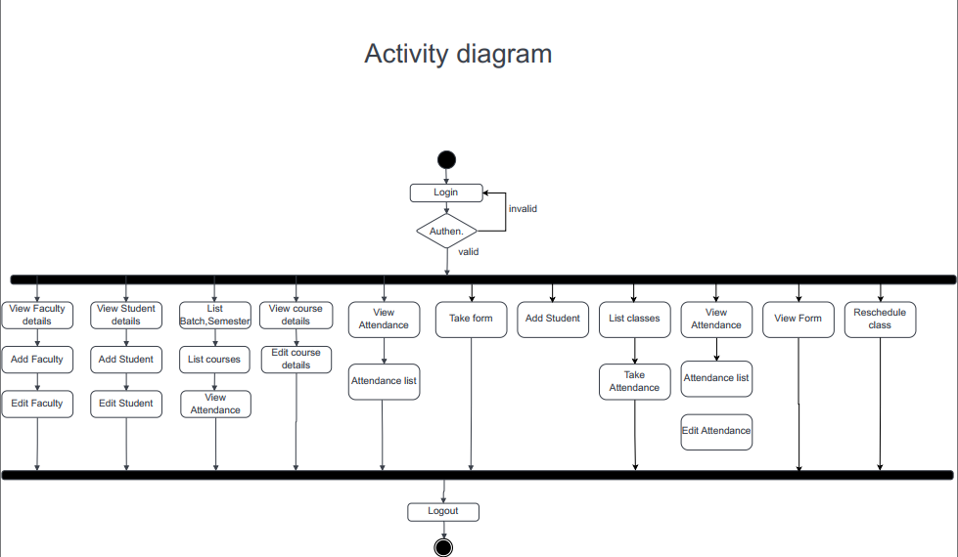

Fig. 5.8 Activity diagram of the system

**5.7.6 ENTITY RELATIONSHIP DIAGRAM**

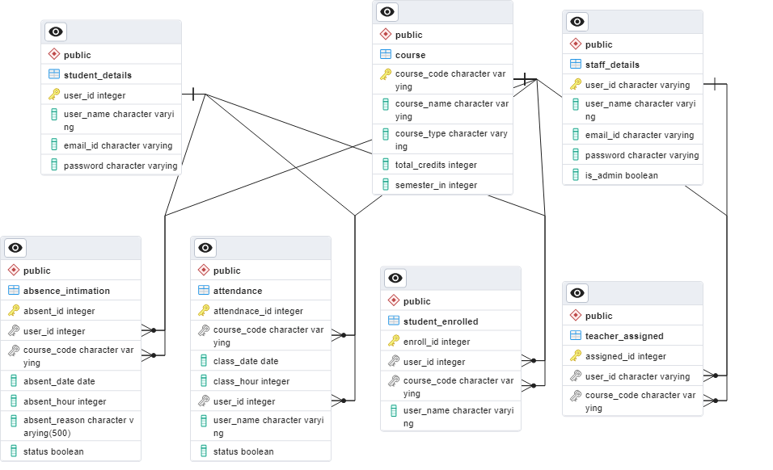

Fig. 5.9 ER diagram for the database of the system

**5.8 SYSTEM EVOLUTION:**

The database of the system is PostgreSQL and designed in such a way that it follows every normalization technique and ACID property so that no error occurs during updating and includes all the necessary details for the system. So in the future, if the system needs to include any functionality or any information in the existing database, it would be easier for them to do so. Also, the system can hold large amounts of data.

The backend programming language is Python and each functionality of the system is written as separate and unique functions and APIs. So in the future, the maintainer or the developer can add new functionality without disturbing the existing one. Even if any functionality needs to be changed, can be found and updated efficiently.

**5.9 APPENDICES:**

The purpose of this appendix is to present the survey we led for evaluation of remedial alternatives in the Feasibility Study. We took an in-person discussion with our primary stakeholder, faculties who gave us the idea to improvise our application with different features including default absent marking using absence initiation forms from the students, filtering the attendance based on a range of dates, automatic freezing mode, calculating attendance based on assessment dates, etc... Then we lead a survey with our secondary stakeholder, students by a Google form and the images of the same are attached below.

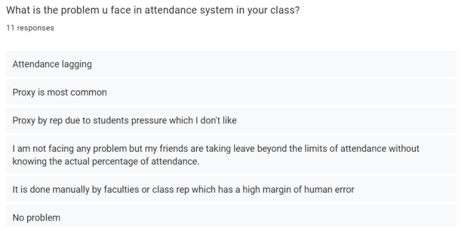

Fig. 5.10 Question1 in Survey

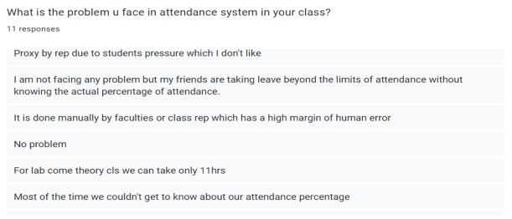

Fig. 5.11 Question2 in Survey

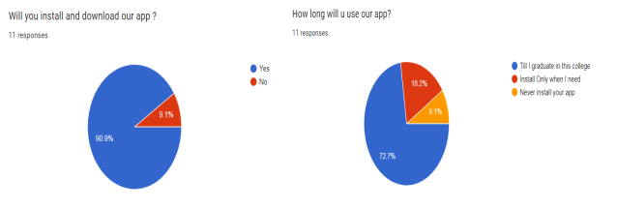

Fig. 5.12 Question3 in Survey Fig. 5.13 Qquestion4 in Survey

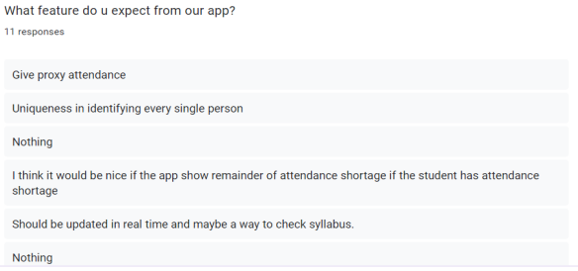

Fig. 5.14 Question5 in Survey

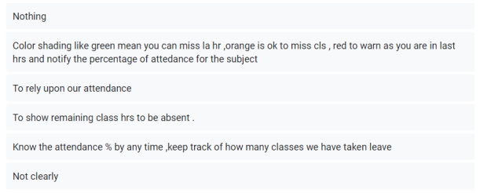

Fig. 5.15 Question6 in Survey

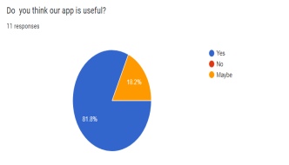

Fig. 5.16 Question5 in Survey

### 5.10 INDEX:

LIST OF DIAGRAMS

|  |  |  |
| --- | --- | --- |
| FIGURE NO. | TITLE | PAGE NO. |

5.1 SYSTEM ARCHITECTURE

5.2 USE CASE DIAGRAM

5.3 CLASS DIAGRAM

5.4 SEQUENCE DIAGRAM-1

5.5 SEQUENCE DIAGRAM-2

5.6 STATE DIAGRAM-1

5.7 STATE DIAGRAM-2

5.8 ACTIVITY DIAGRAM

5.9 ER DIAGRAM

6.1 SYSTEM ARCHITECTURE

7.1 USE CASE DIAGRAM

7.2 CLASS DIAGRAM

7.3 SEQUENCE DIAGRAM-1

7.4 SEQUENCE DIAGRAM-2

7.5 STATE DIAGRAM-1

7.6 STATE DIAGRAM-2

7.7 ACTIVITY DIAGRAM

7.8 ER DIAGRAM

LIST OF FIGURES

|  |  |  |
| --- | --- | --- |
| FIGURE NO. | TITLE | PAGE NO. |

5.10 QUESTION 1 IN SURVEY

5.11 QUESTION 2 IN SURVEY

5.12 QUESTION 3 IN SURVEY

5.13 QUESTION 4 IN SURVEY

5.14 QUESTION 5 IN SURVEY

5.15 QUESTION 5 IN SURVEY

5.16 QUESTION 6 IN SURVEY

8.1 USER INTERFACE

8.2 BACKEND

8.3 DATABASE